Sam McDowell

7/1/2020

Lab 2.1B

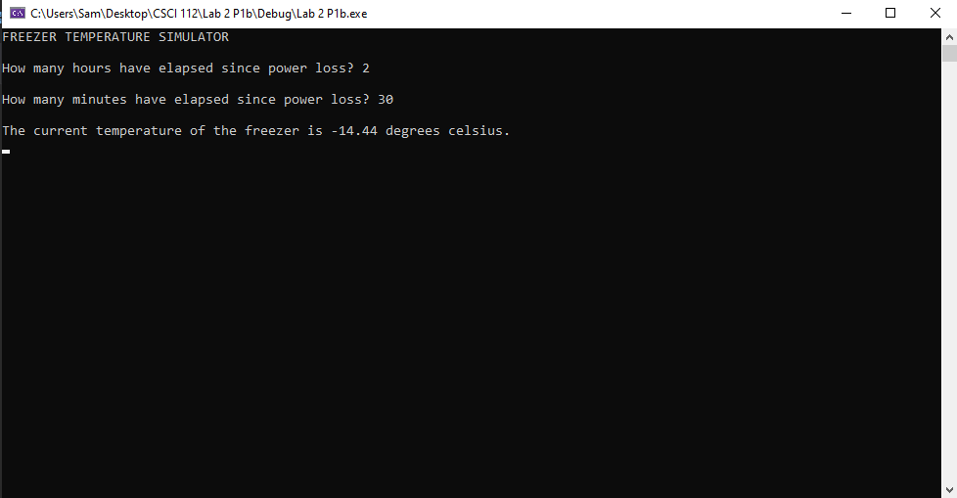

# Transcription:

FREEZER TEMPERATURE SIMULATOR

How many hours have elapsed since power loss? 2

How many minutes have elapsed since power loss? 30

The current temperature of the freezer is -14.44 degrees celsius.